1:CONFERENCE MANAGEMENT SYSTEM

USE CASE DIAGRAM:

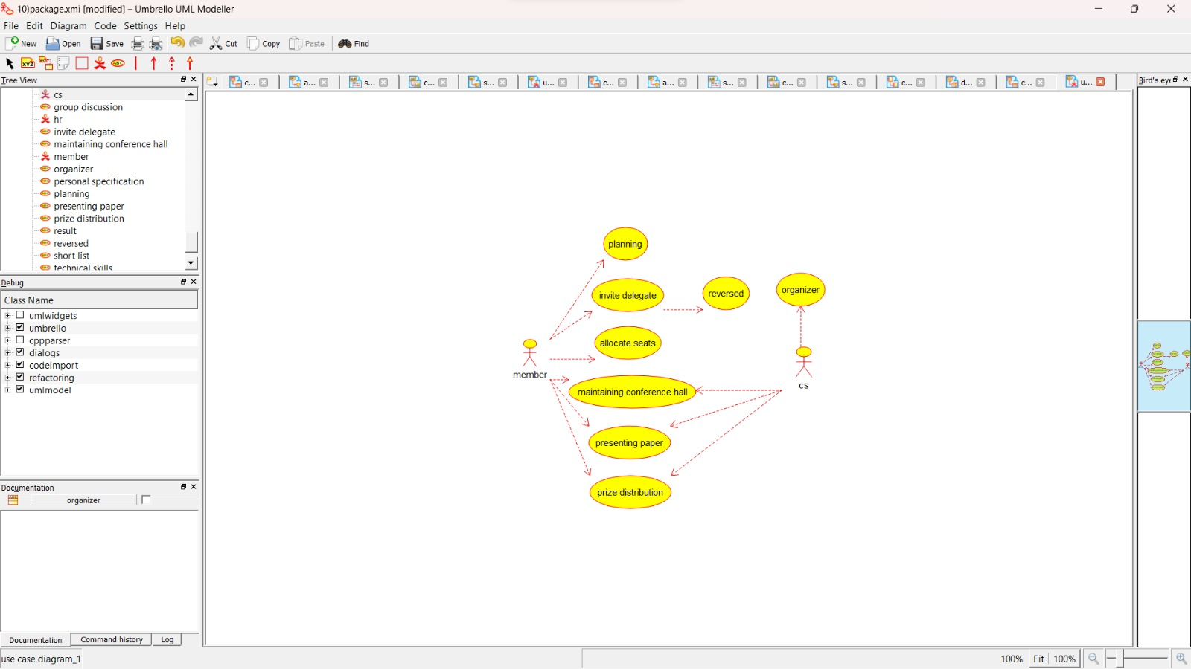

CLASS DIAGRAM:

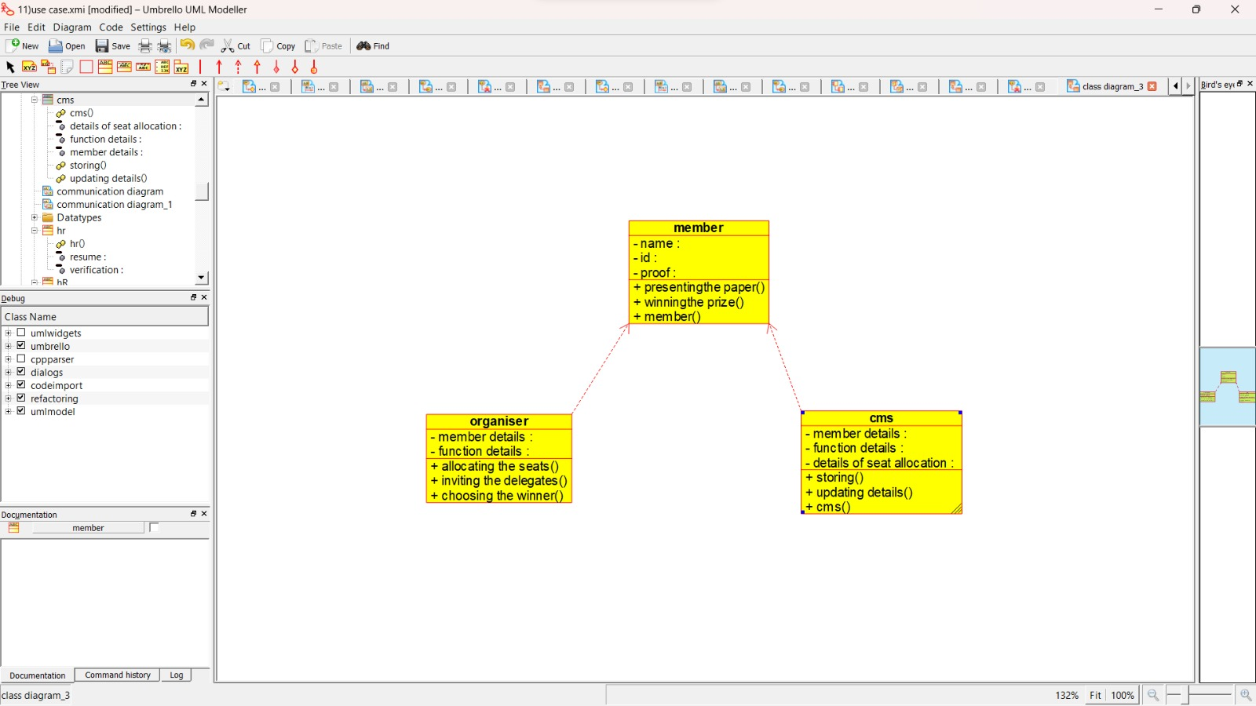

ACTIVITY DIAGRAM:

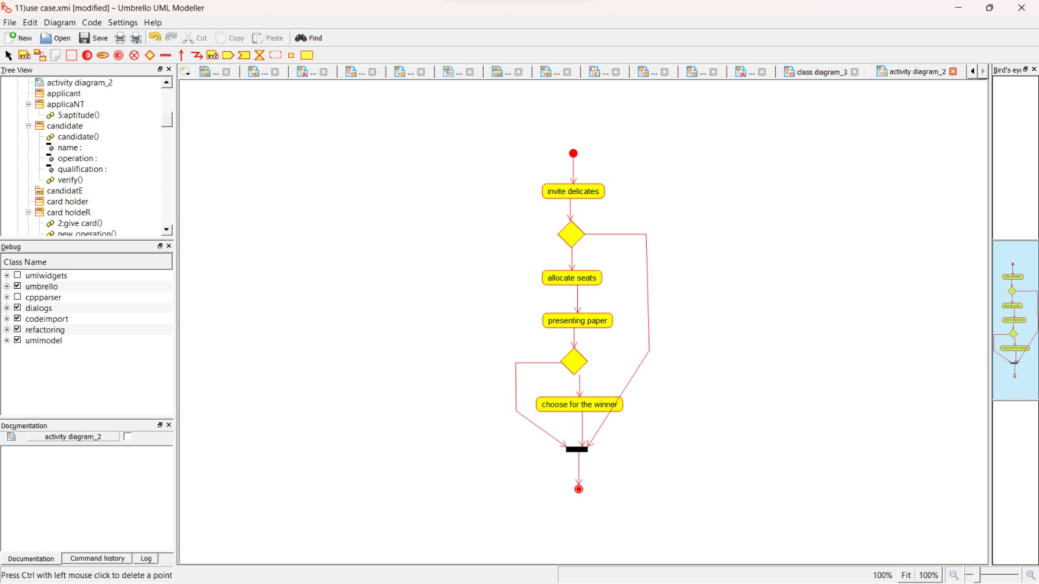

COLLABORATION DIAGRAM:

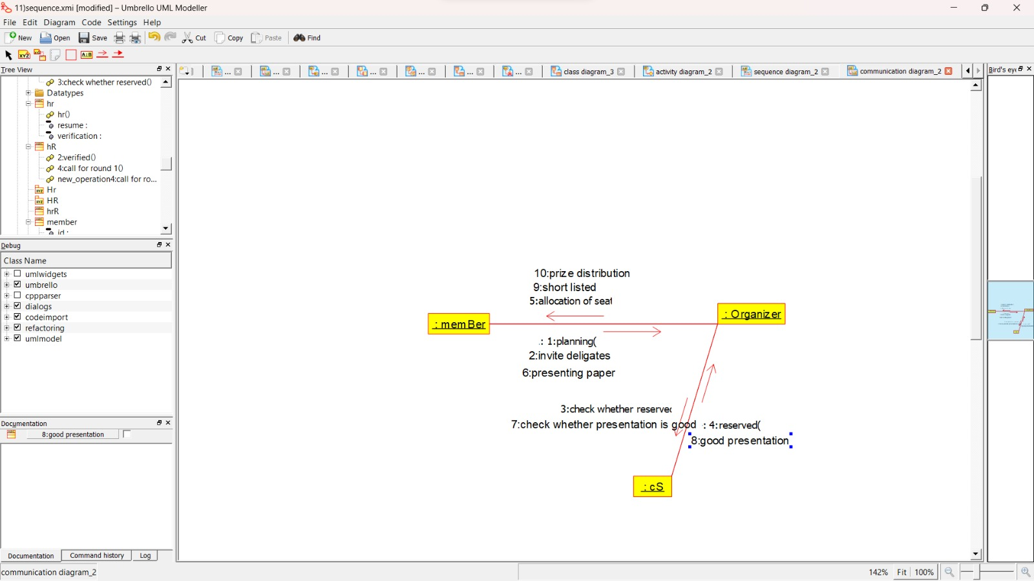

SEQUENCE DIAGRAM:

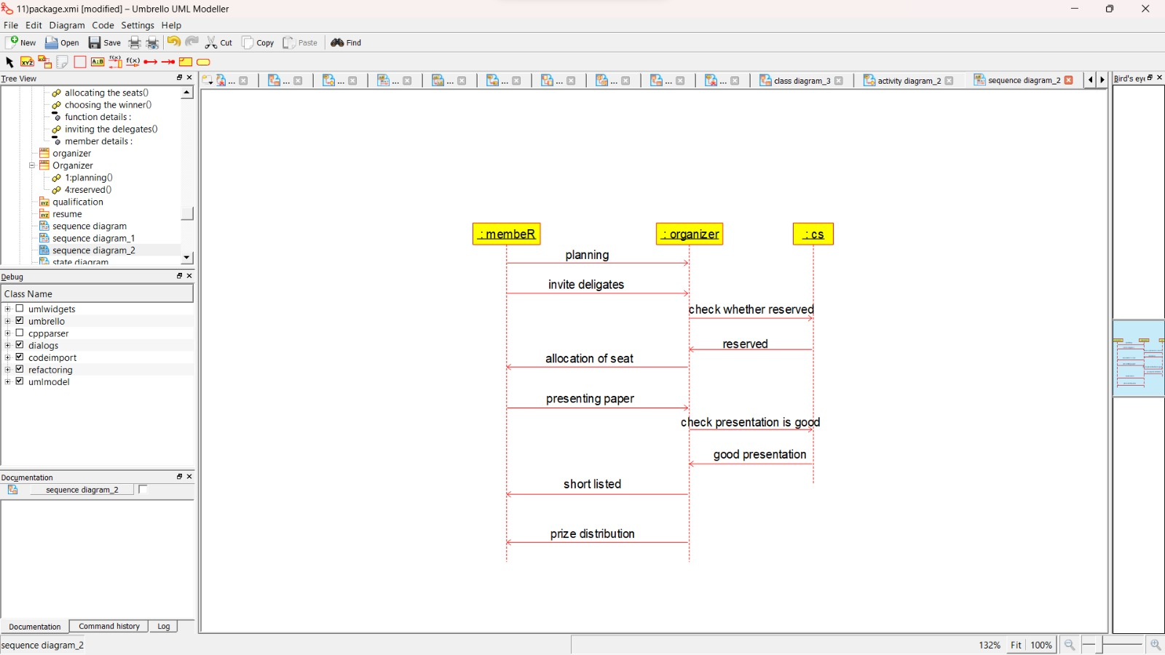

COMPONENT DIAGARM:

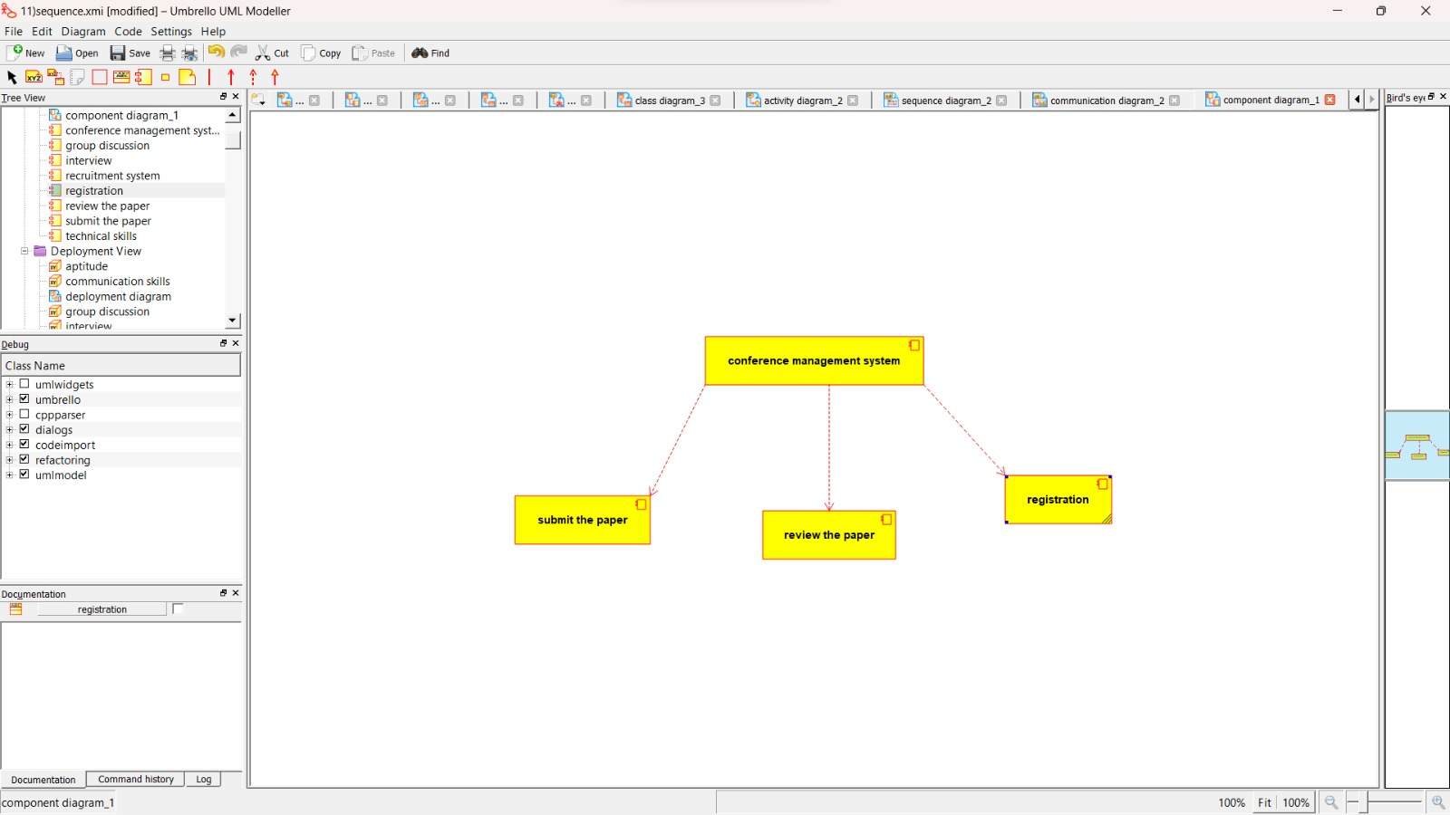

DEPLOYMENT DIAGRAM:

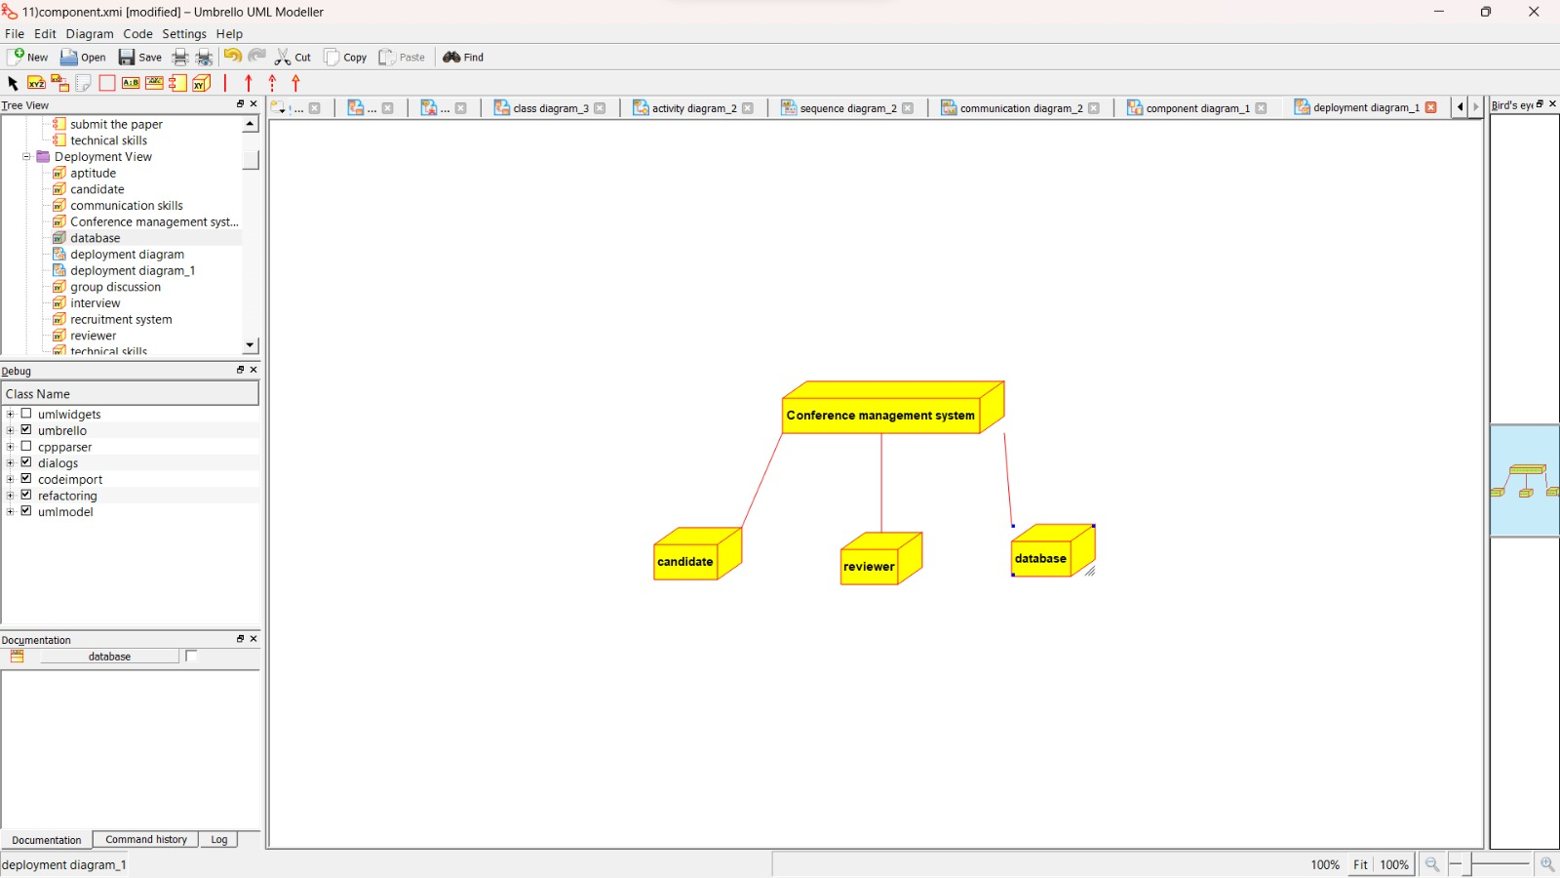

PACKAGE DIAGRAM:

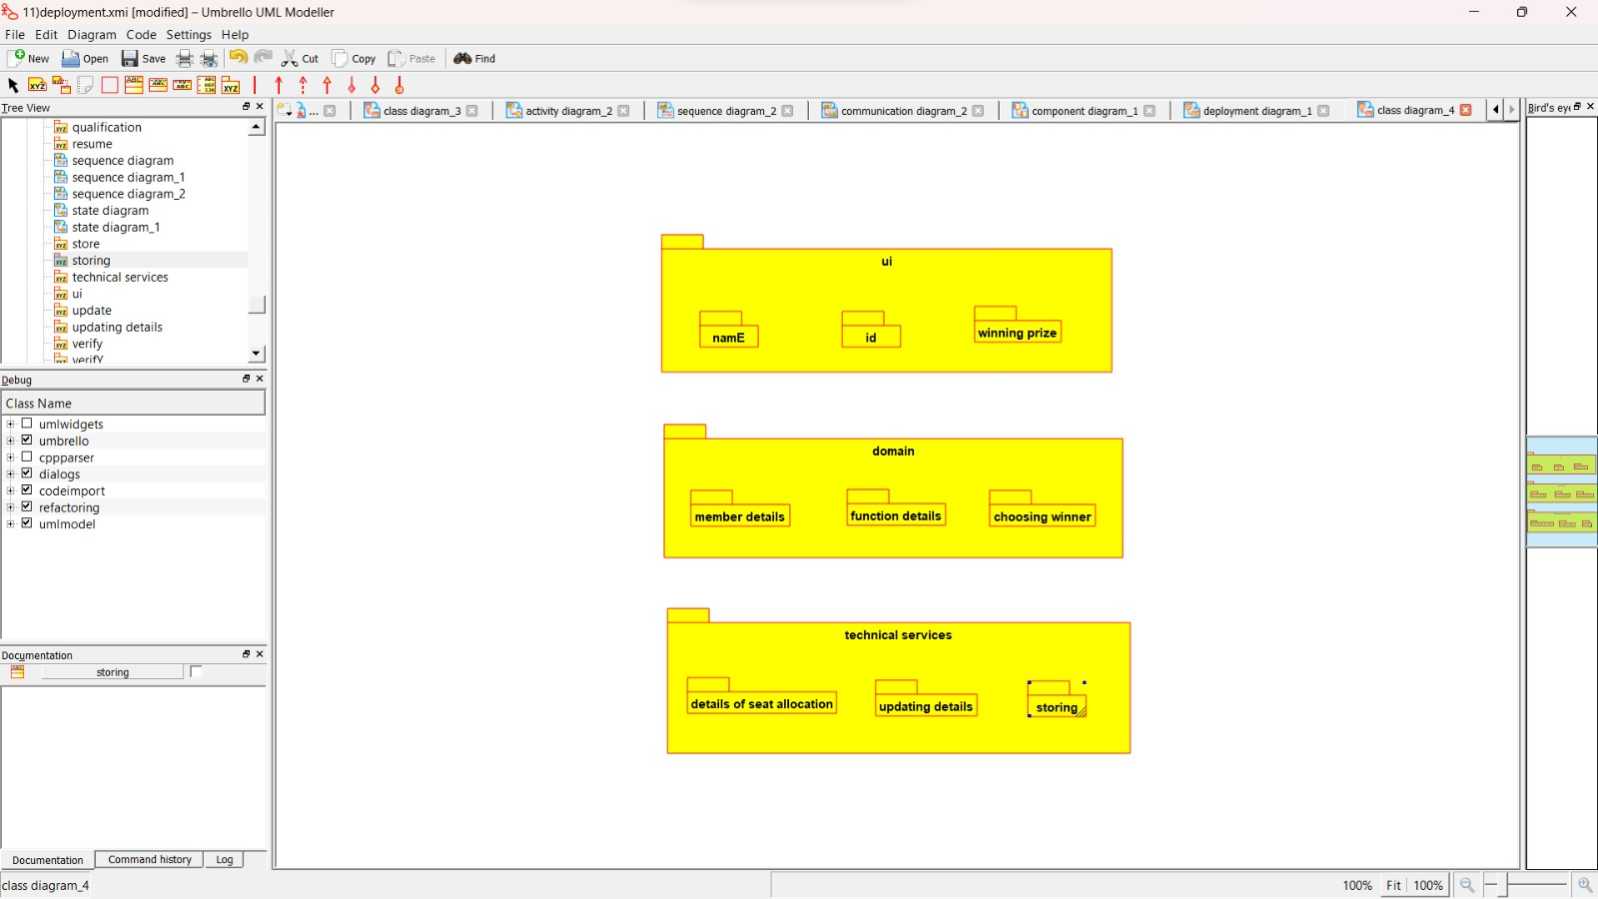

2:FOREIGN TRADING SYSTEM

USE CASE DIAGRAM:

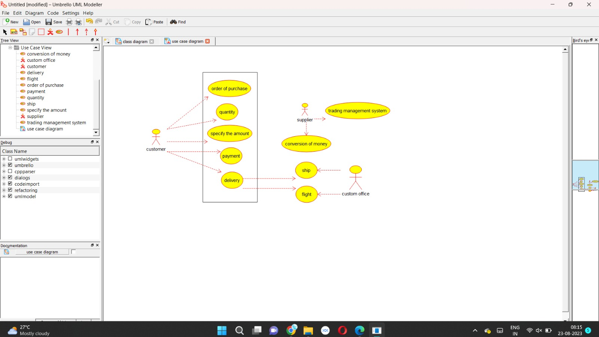

CLASS DIAGRAM:

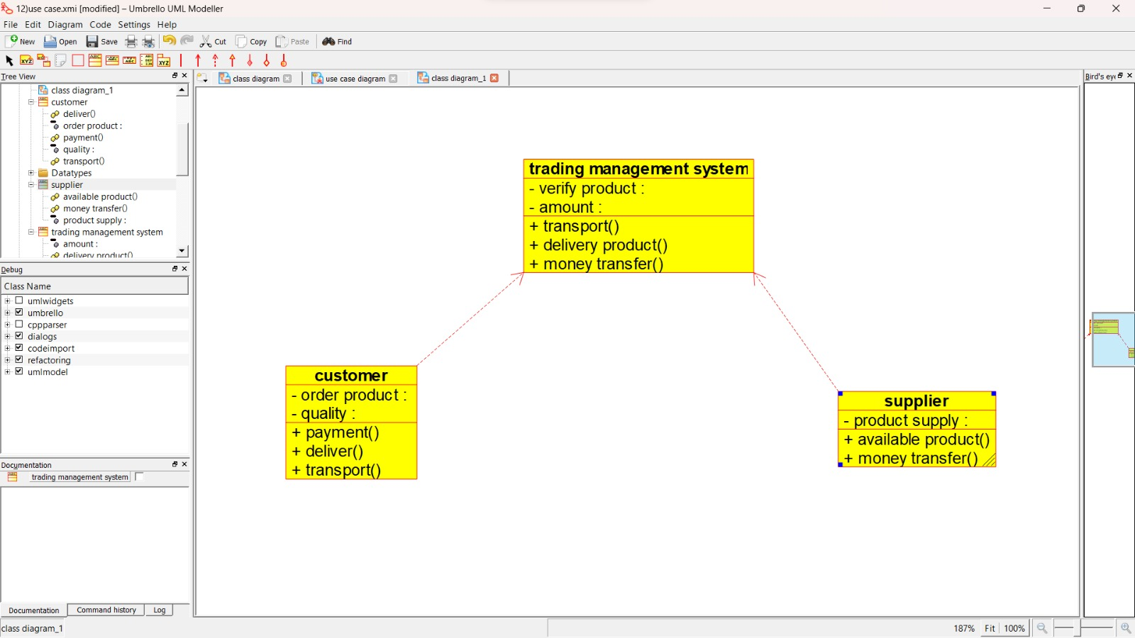

ACTIVITY DIAGRAM:

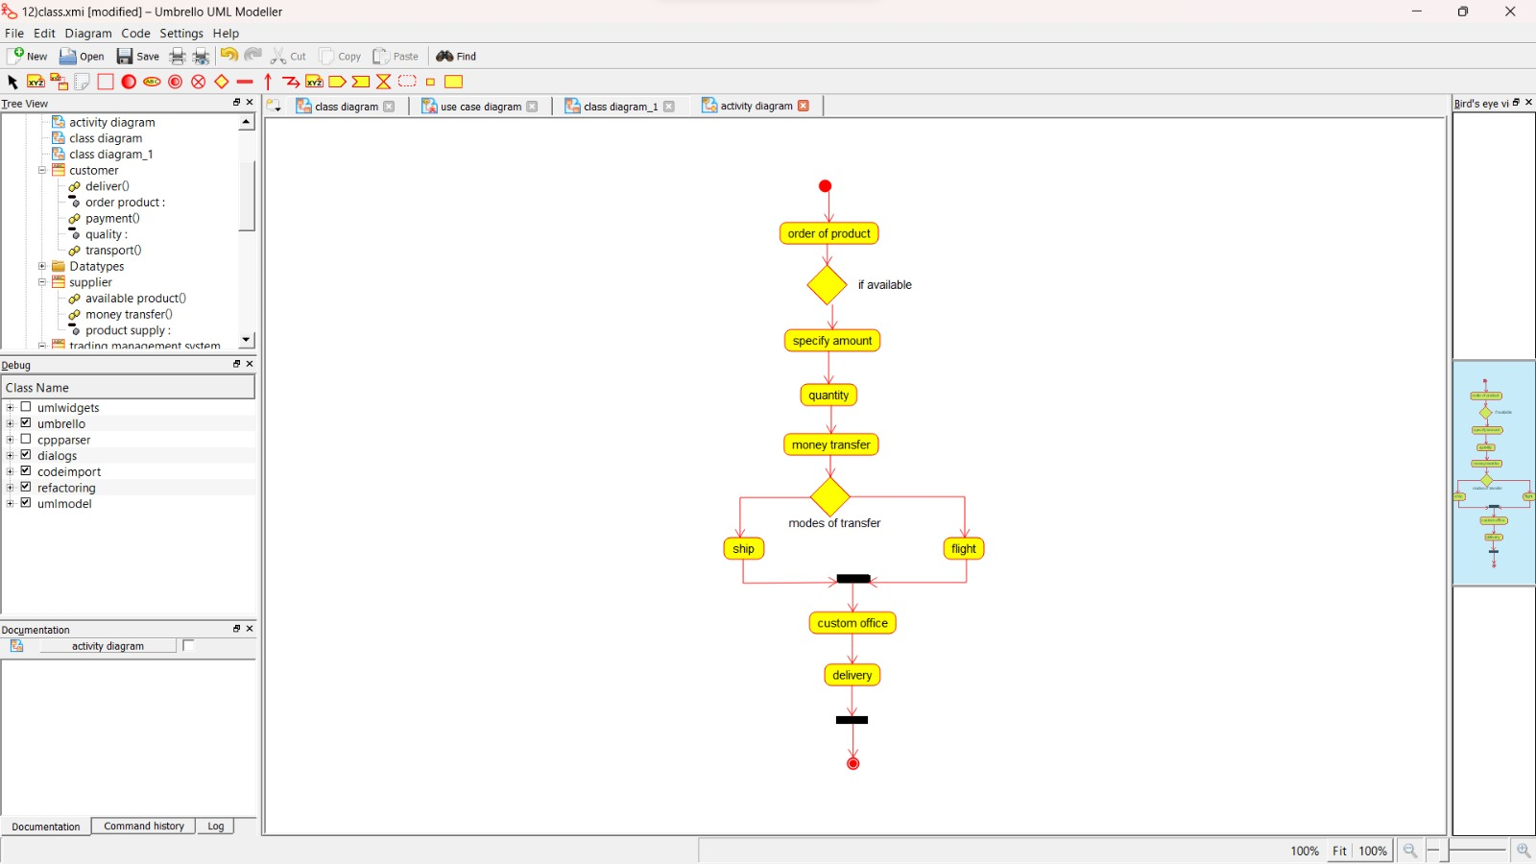

SEQUENCE DIAGRAM:

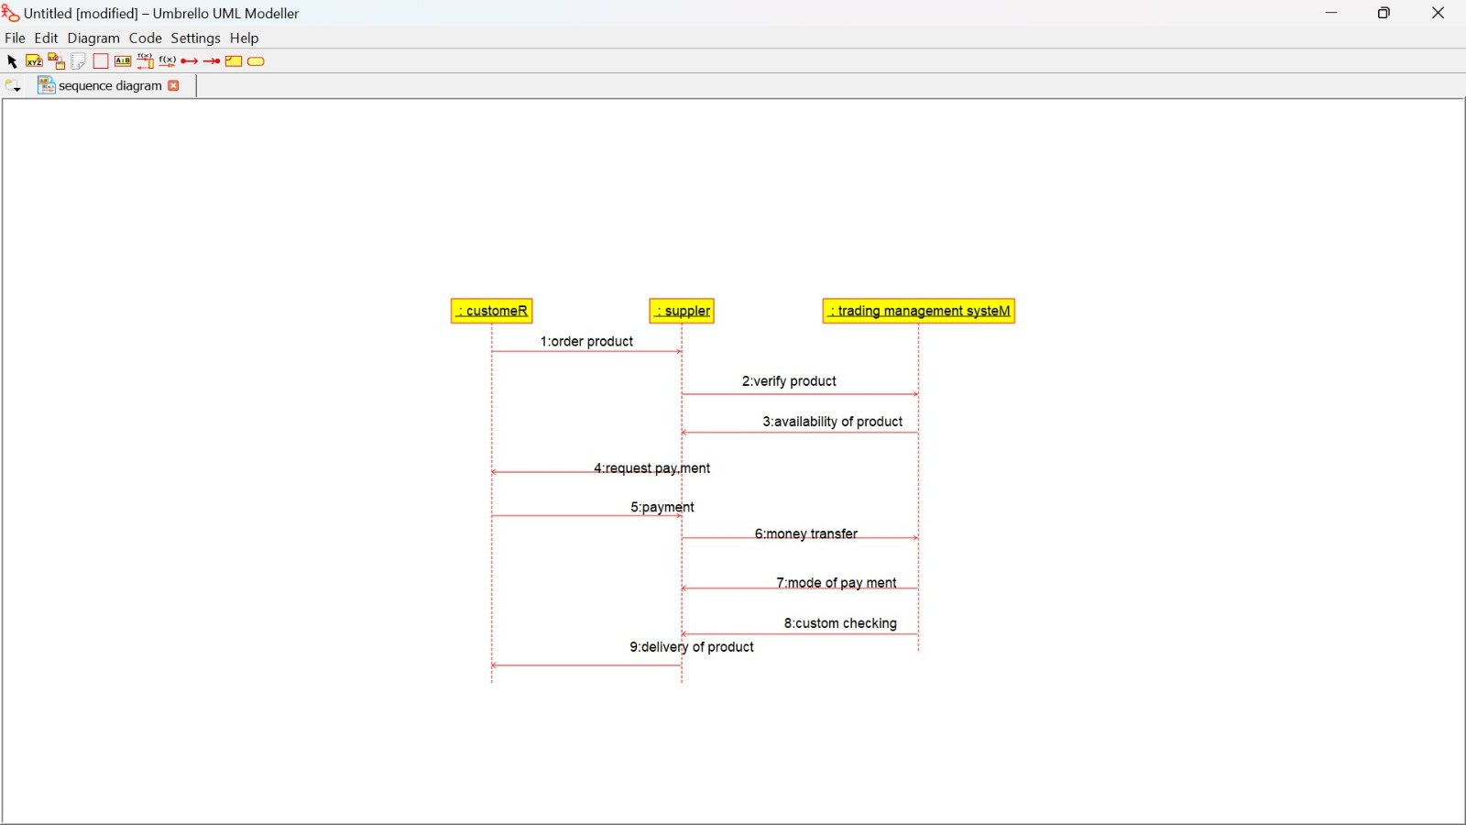

COLLABORATION DIAGRAM:

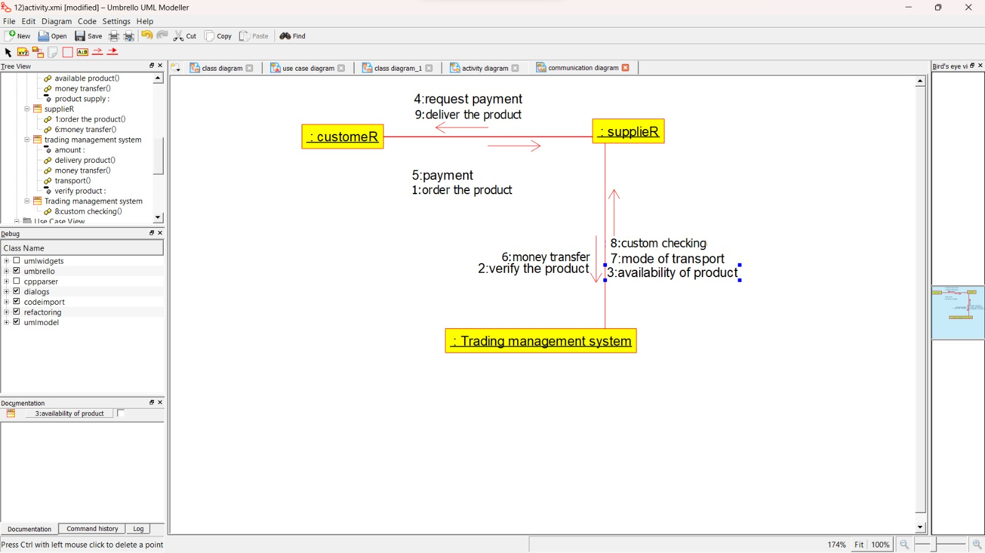

STATE CHART DIAGRAM:

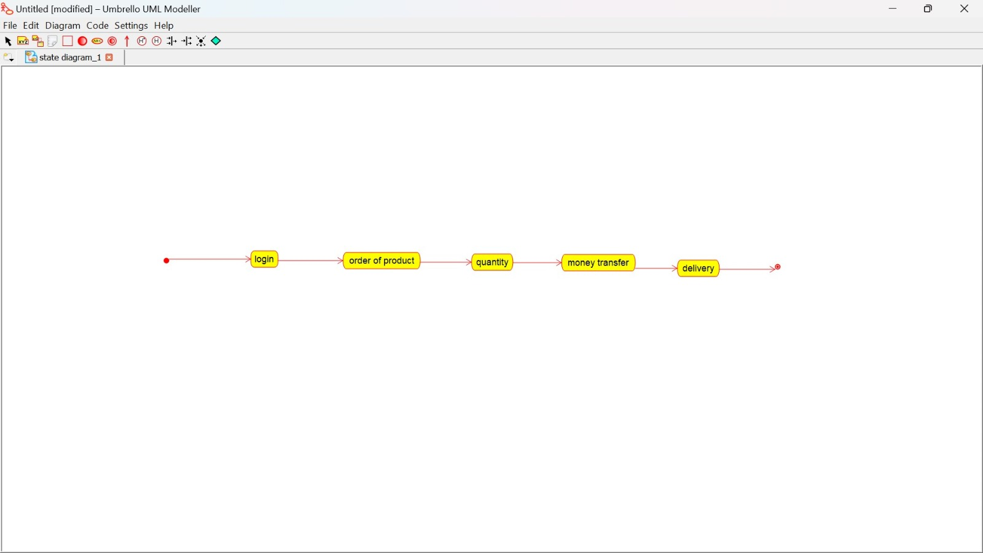

COMPONENT DIAGRAM:

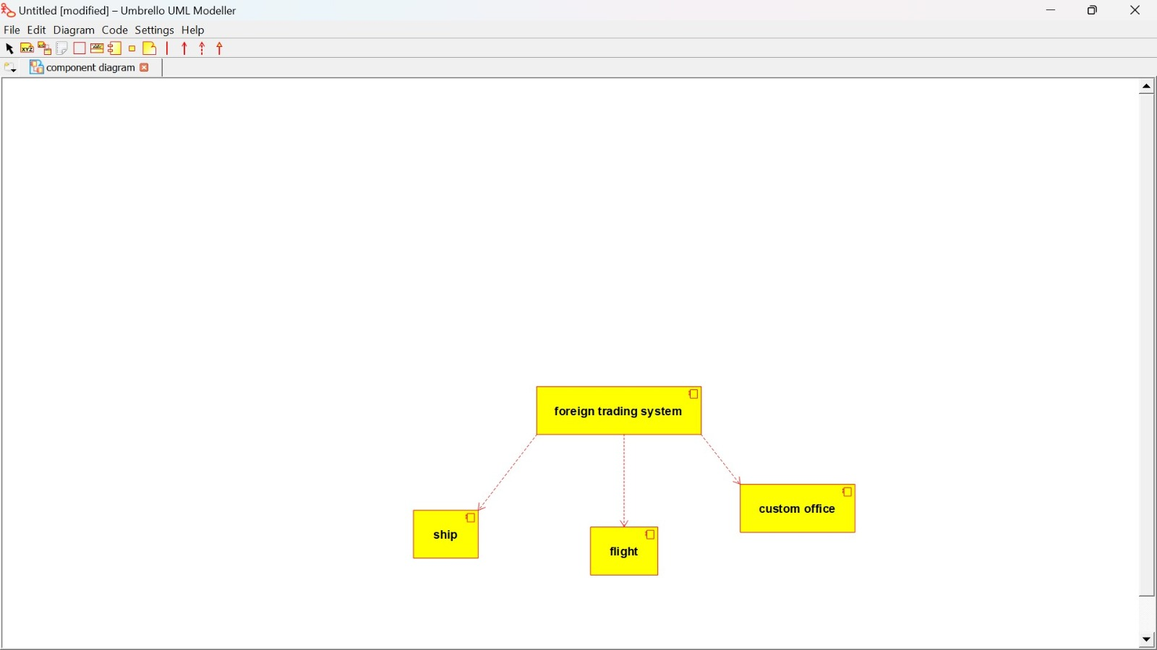

DEPLOYMENT DIAGRAM:

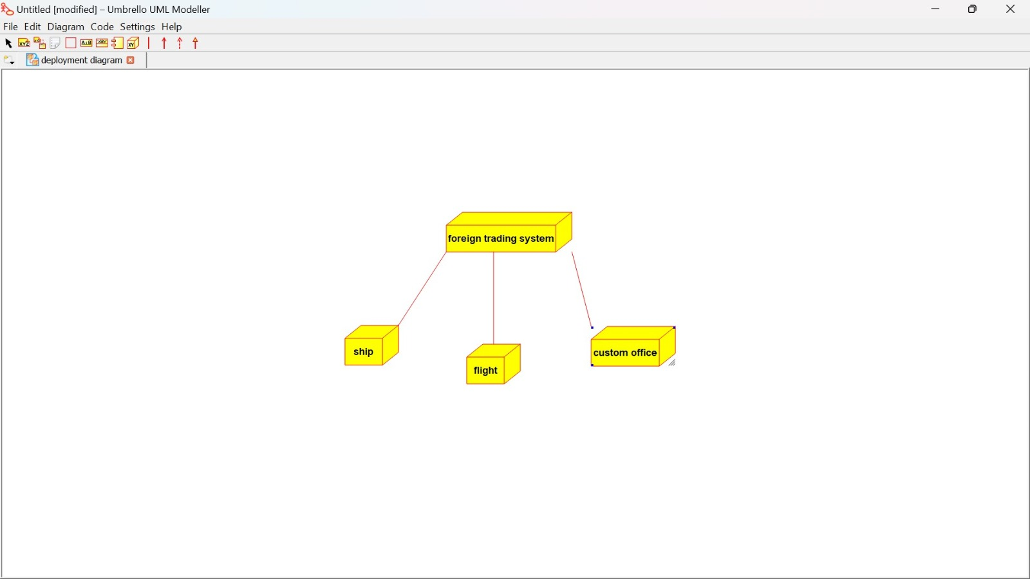

PACKAGE DIAGRAM:

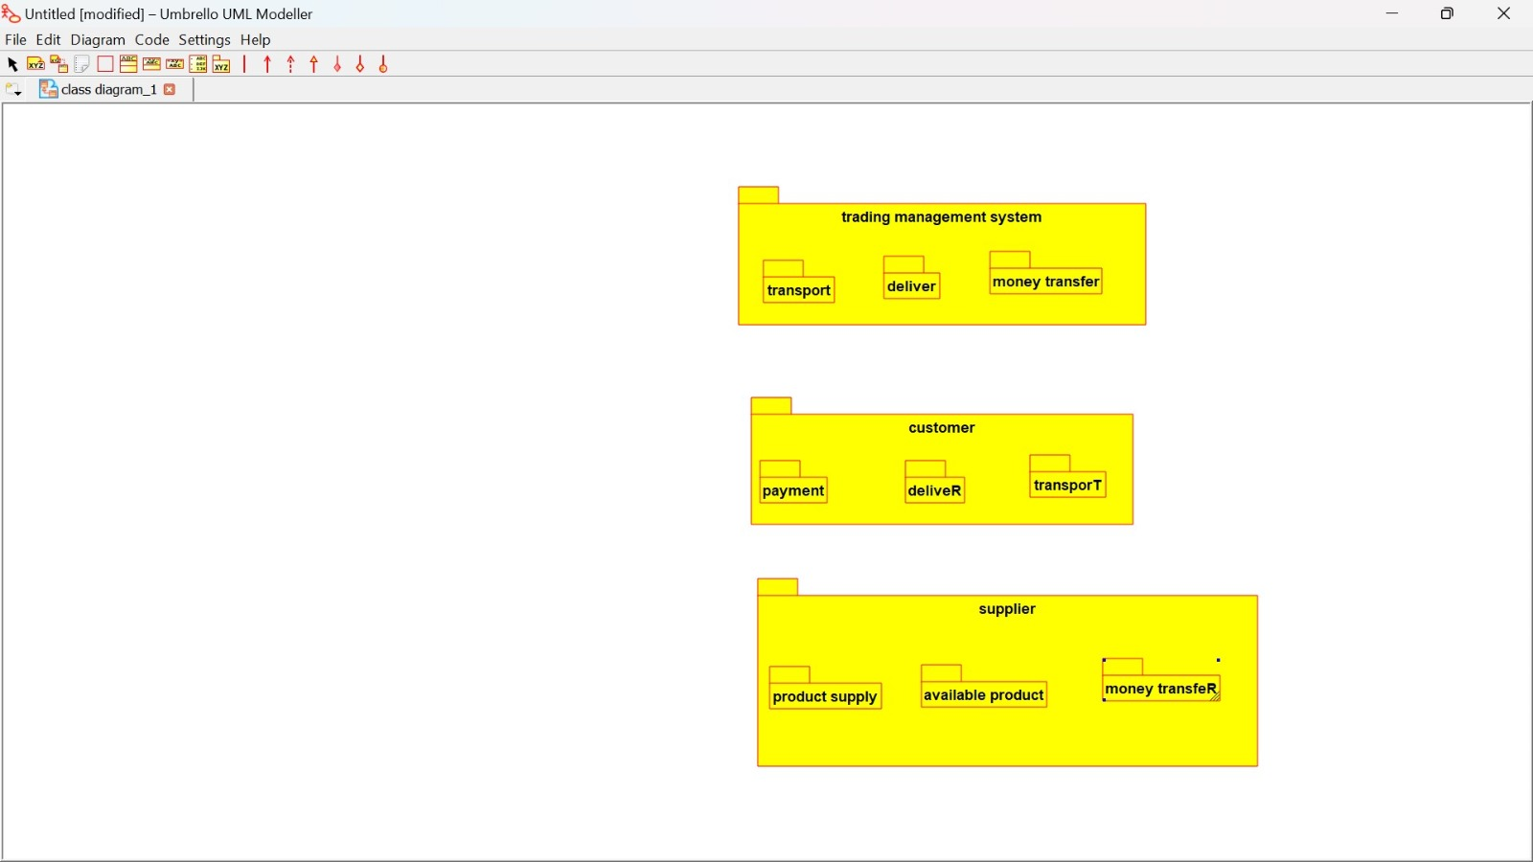

3:BPO MANAGEMENT SYSTEM

USE CASE DIAGRAM:

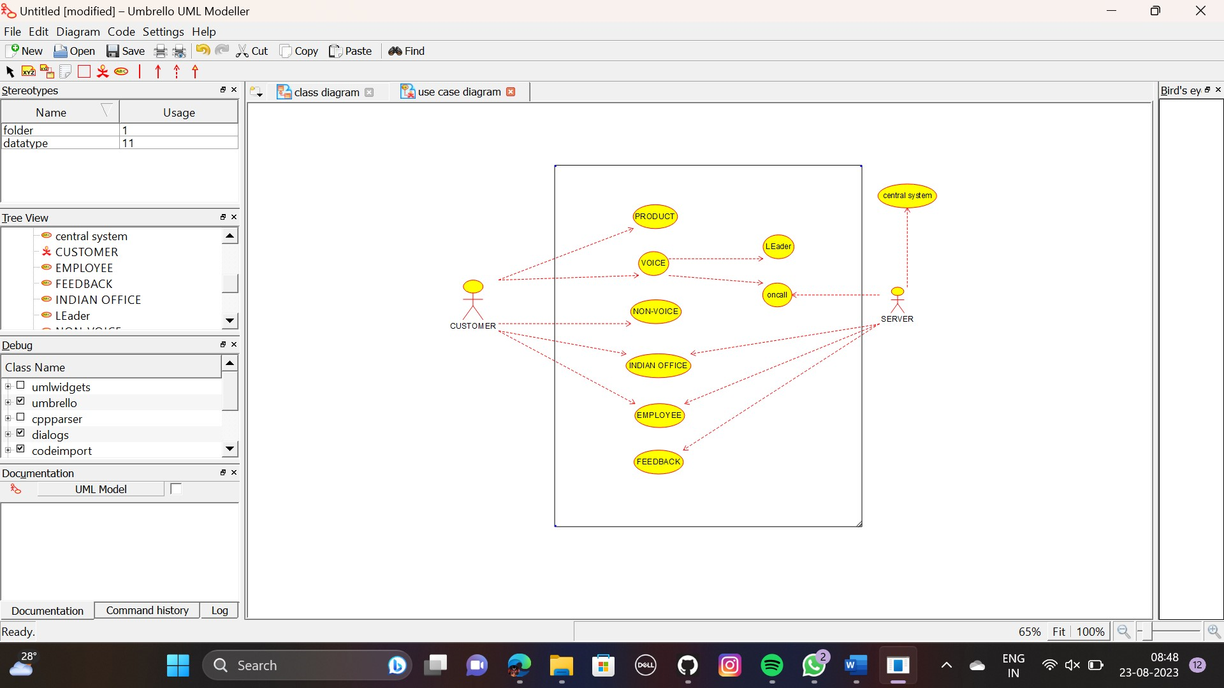

CLASS DIAGRAM:

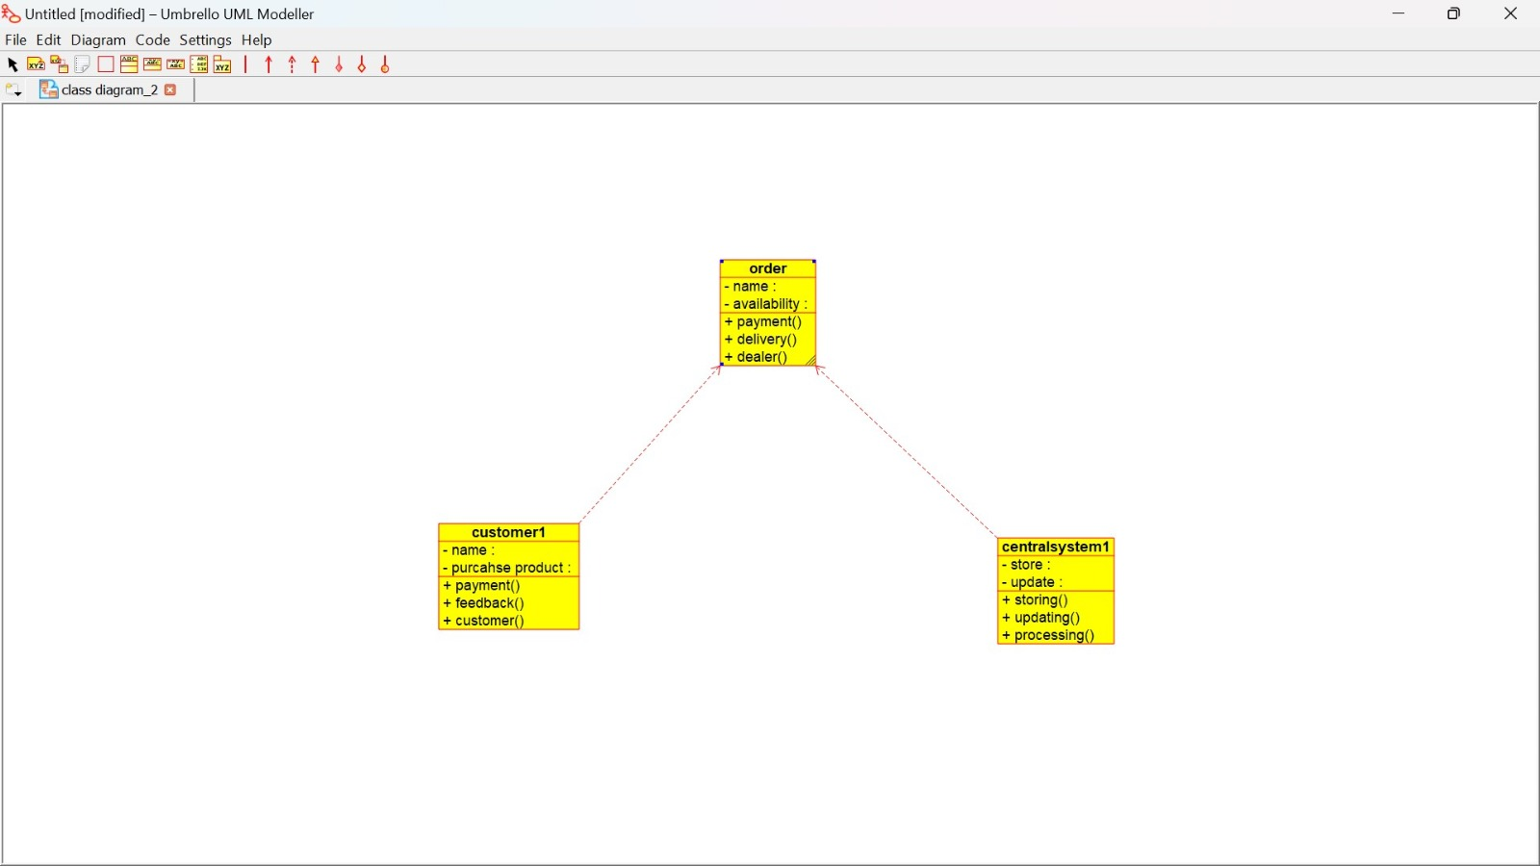

ACTIVITY DIAGRAM:

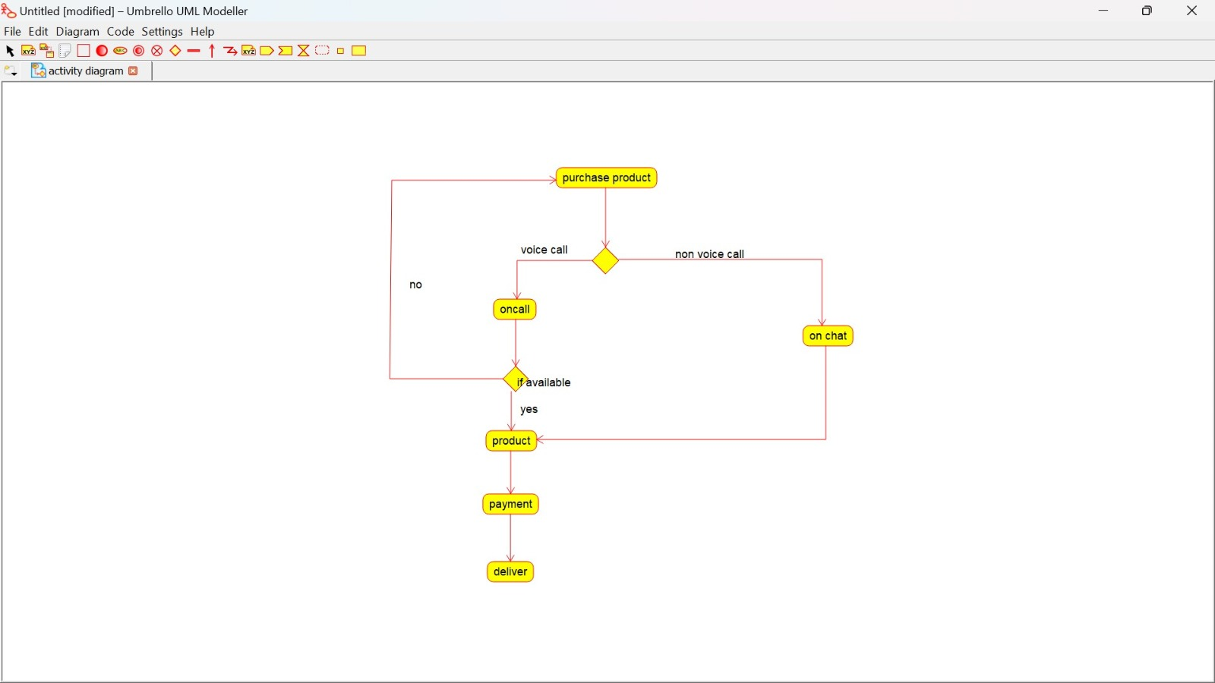

SEQUENCE DIAGRAM:

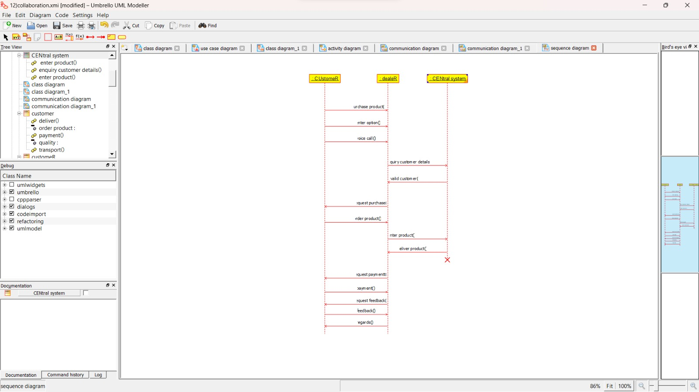

COLLABORATION DIAGRAM:

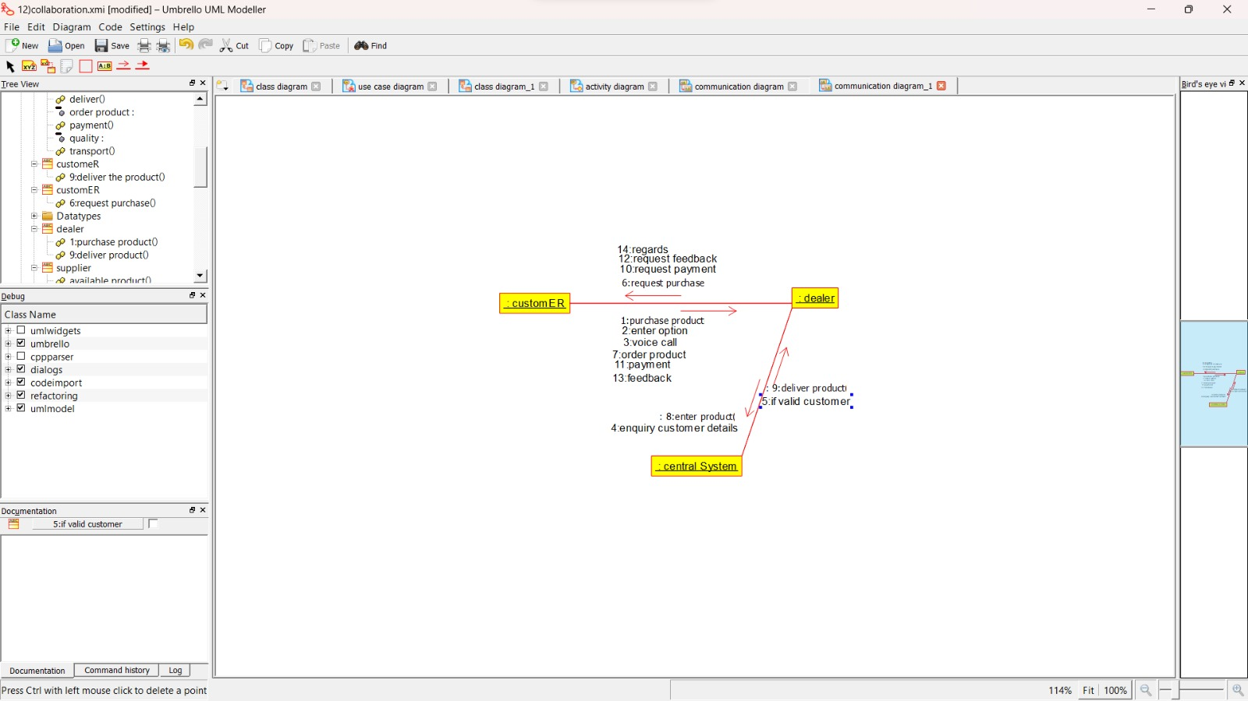

STATE CHART DIAGRAM:

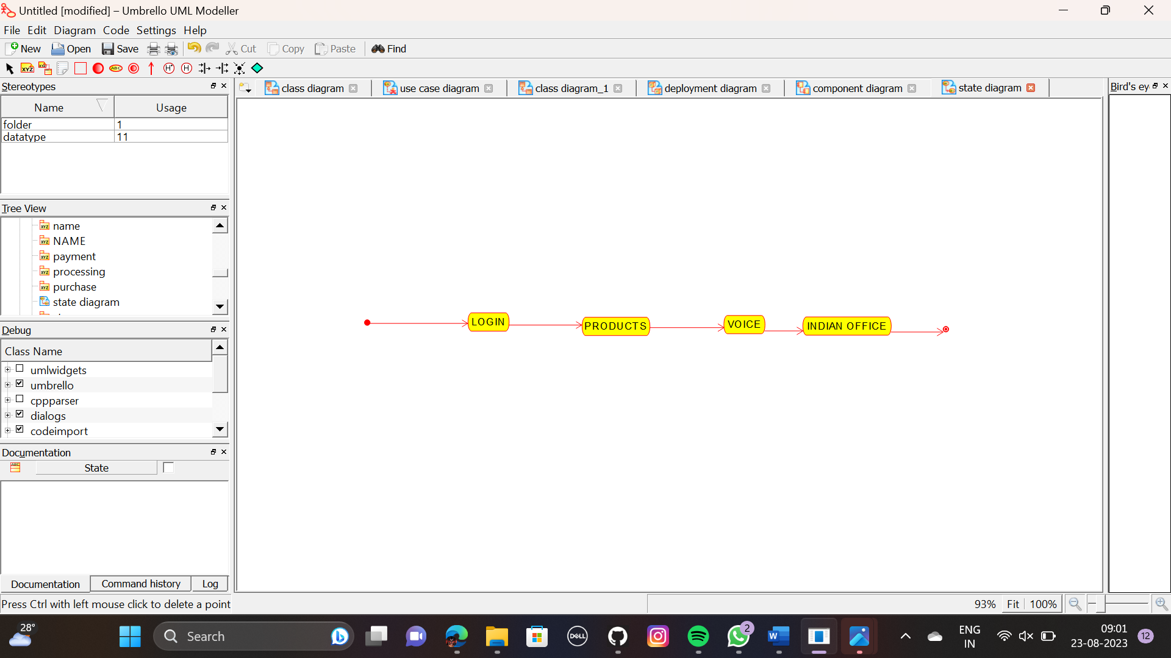

COMPONENT DIAGRAM:

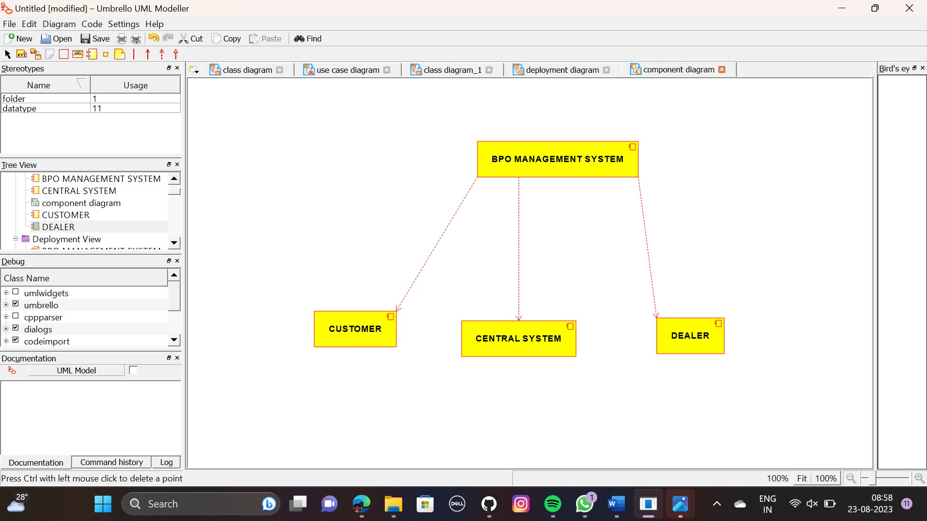

DEPLOYMENT DIAGRAM:

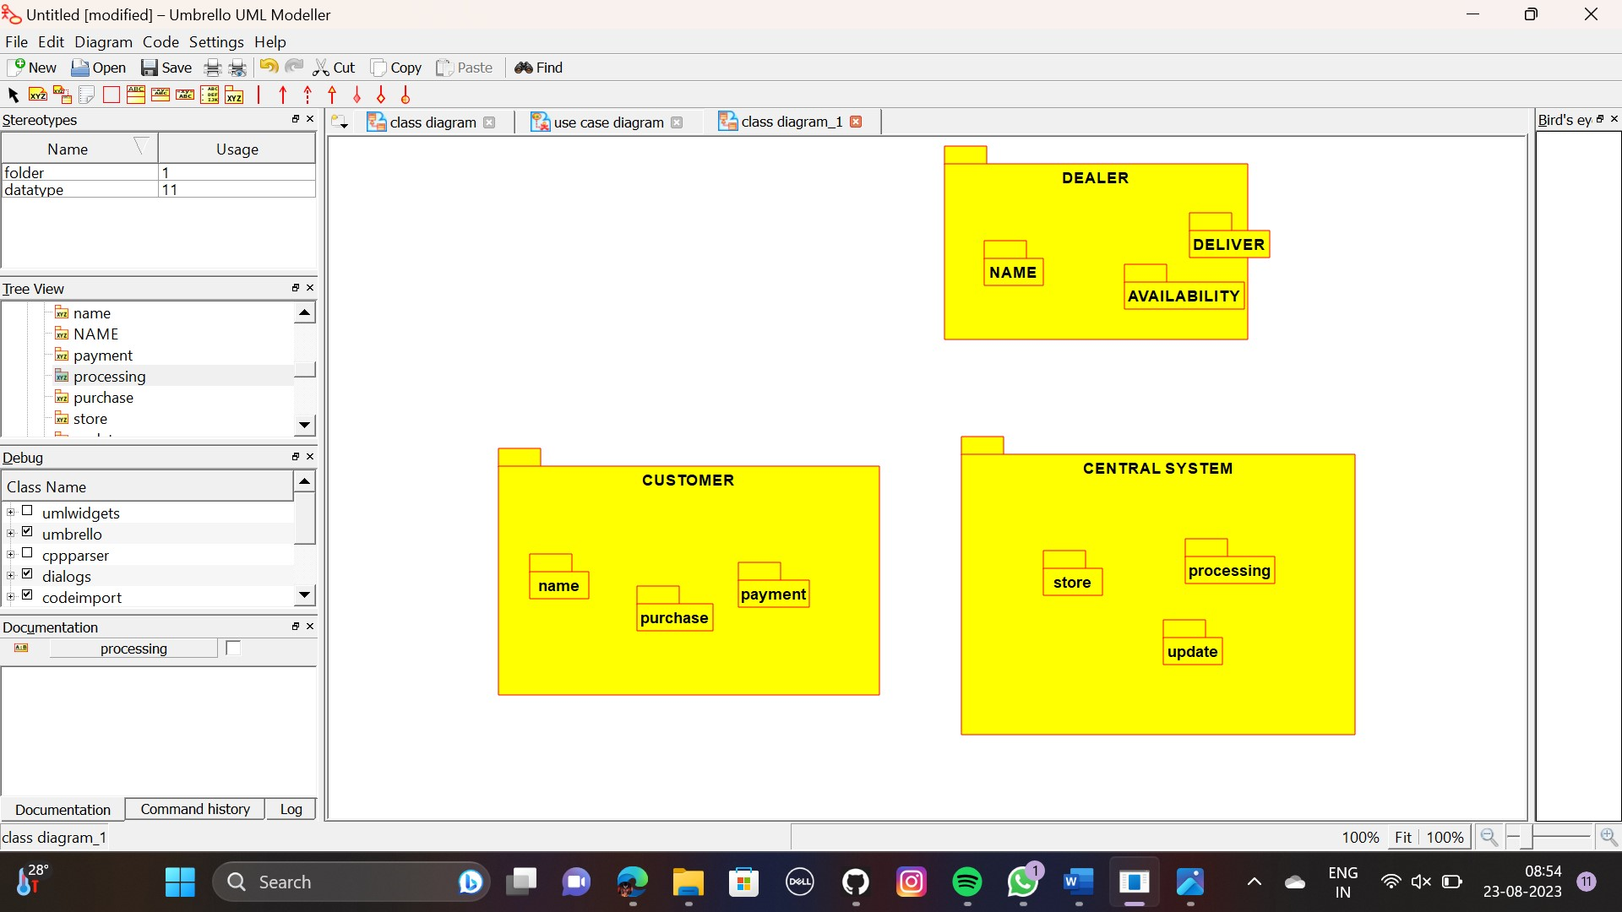

PACKAGE DIAGRAM:

